Delta Loop Antenna Radiation Patterns
The 80 meter Delta Loop is mounted in a vertical plane.
The base of the Delta Loop is only 10 feet above average ground.

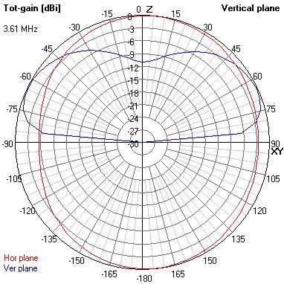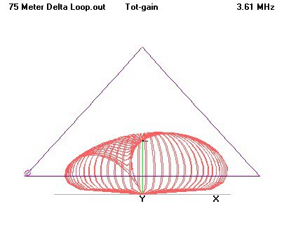

The two above pictures show the radiation pattern of the Delta Loop fed in the bottom corner of the antenna.
Note the low angle of radiation.
This configuration is best suited for working long haul DX.

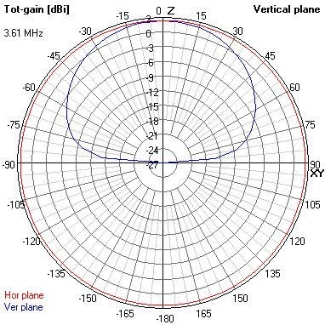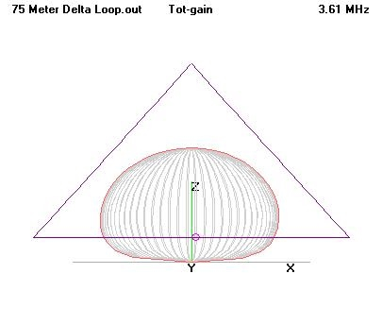

The two above pictures show the radiation pattern of the Delta Loop fed in the center of the base of the antenna.
Note the very high angle of radiation.
This configuration is more suitable for working close in stations.

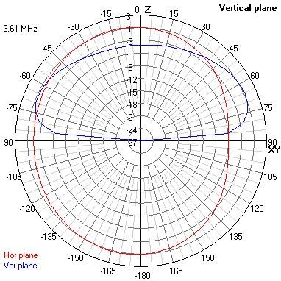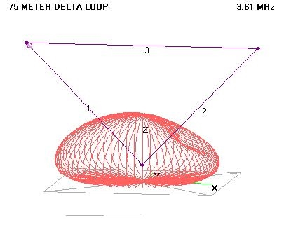

The two above pictures show the radiation pattern of the Inverted Delta Loop fed in the top left corner.
Note the low angle of radiation.
This configuration is best suited for working long haul DX.

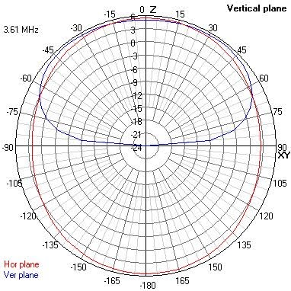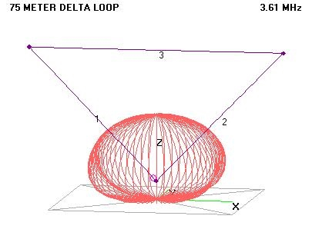

The two above pictures show the radiation pattern of the Inverted Delta Loop fed at the bottom of the antenna.
Note the very high angle of radiation.
This configuration is more suitable for working close in stations.

